Project description

# Background information

We are a team of students who are working on an assignment. A part of the assignment is to outsource the development of an app, which is why we have created this job on Upwork.

# Product description

The final product is an app where you can enter the name of a European country (a list of European countries is provided in Append 3) and when you click a ‘submit’ button the app shows information on the given country. The information is provided by the JSON endpoint described in Appendix 1.

# Product requirements

The final product is an app that fulfils the following requirements:

* The app must be built using the React Native framework
* The app must be functional on the newest version of iOS and/or Android
* The app fetches and shows all data from the JSON endpoint described in Appendix 1
* The app has a similar design (colours and buttons) as the prototype provided in Appendix 2

# Deadline

The app must be delivered via GitHub or similar service no later than December 8th 2020.

# Appendix 1 – API documentation

If the URL provided in the table below is not working, this URL can be used as back-up:

https://www.annemaj.dk/sem3back/api/destination/open/{countryName}

|  |  |  |
| --- | --- | --- |
| **Method** | **URL** | **Response (JSON)** |
| **GET** | https://www.claesvonh.dk/sem3back/api/destination/open/{countryName} | Country(1) |

### Request Body and Response Formats

**Country (1)**

 {  
"name": String,  
"capital": String,  
"population": Long,

"currencies": {

“code”: String

},

"fxRate": Double,

“last_update”: String,

“cases”: Long,

“deaths”: Long,

“recovered”: Long  
  }

### Explanation of the response elements in Country(1):

* **name:** Name of the country
* **capital:** Capital city of the country
* **population:** Total population of the country
* **currencies, code:** 3-digit ISO code for currency code of the country
* **fxRate:** Rate of the country’s currency against USD
* **last_update:** Timestamp for latest update of data ‘cases’, ‘deaths’ and ‘recovered’
* **cases:** Total number COVID-19 cases in the country
* **recovered:** Total number of persons recovered from COVID-19 in the country

# Appendix 2 – Design

The design of the app must be similar to this prototype:

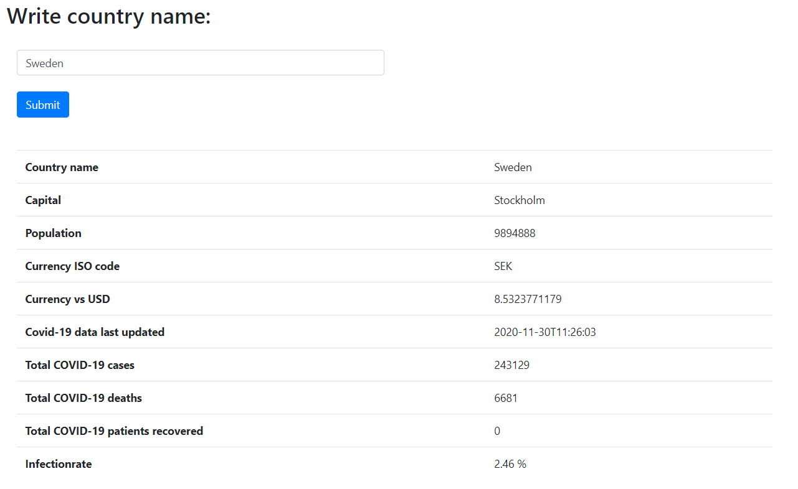

The data shown below the ‘Submit’ button should only be visible after the ‘Submit’ button has been clicked.

# Appendix 3 – List of European countries

For test purposes please use this list of European countries (it is not mandatory that you test the app with all the countries in the list):

|  |
| --- |
| * Albania |
| * Czech Republic |
| * Denmark |
| * Andorra |
| * Austria |
| * Belgium |
| * Cyprus |
| * Estonia |
| * Finland |
| * France |
| * Germany |
| * Greece |
| * Ireland |
| * Italy |
| * Latvia |
| * Lithuania |
| * Luxembourg |
| * Malta |
| * Monaco |
| * Montenegro |
| * Netherlands |
| * Portugal |
| * San Marino |
| * Slovakia |
| * Slovenia |
| * Georgia |
| * Croatia |
| * Hungary |
| * Iceland |
| * Norway |
| * Poland |
| * Sweden |